SOFTWARE DEVELOPMENT LIFE CYCLE
Software Development Life Cycle contains six phases
1. Requirement Phase (Planning)
2. Analysis Phase
3. Design Phase
4. Coding Phase
5. Testing Phase
6. Maintenance Phase

PLANNING PHASE – REQUIREMENTS GATHERING
Project Definition:
This project will be a Content Management System based “Pet Profile” website that will allow users to view multiple individual profiles for each of the pets I have at home. Each profile will contain information about their personality and care requirements. Users will also be able to like and comment on any of the profiles they choose.
Business Case and Concepts:
This System will be required to store user information such as Names, Emails, passwords and birthdays securely as well as track likes and comments for each user’s respective account.
Risks and Solutions:
Risk (Technical): Data breaches regarding personal data and user authentication
Reason: Code vulnerabilities can sometimes allow threat actors to steal user information
Solution: Implement strong password policies and encryption, enforce frequent updates of the system, and use built in security plugins if available
Risk (Non-Technical): Unclear or expanding project scope
Reason: Adding unnecessary additional features may expand the project size and scope to beyond the available time for the course
Solution: Clearly define project requirements during the planning phase and limit features to only the required features for a secure and functional project
Technical Approaches:
WordPress will be the leading software for this project. WordPress is a good choice because it has built-in features for restricting admin access, creating, modifying or deleting posts without modifying source code, and automatic updates. WordPress is also widely used worldwide and well-documented. It’s also free.
Security will be achieved through SSL encryption, role-based access control, security plugins, regular backups and strong password policies
The expected outcome of this project will be a functional and secure website built using a Content Management System that allows for administrators to create posts and undergo updates without excessive technical knowledge as well as to allow registered users to view, like, and comment on those posts
ANALYSIS PHASE
Feasibility assessment:
Financial Feasibility
The project is technically feasible as WordPress can be run on many kinds of hardware without very many hardware resources. WordPress can be run on a personal computer, laptop, or even a Raspberry Pi microcomputer. WordPress itself also comes at no cost. The technical requirements for this project are already met
Financial Feasibility
The project is financially feasible too and for most of the same reasons it is technically feasible. WordPress can run on cheap hardware and WordPress itself includes no purchases. The project is not designed to procure revenue. However, if the site grows to a point where the size is unmanageable for one person, it could switch to having some ads for income to pay staff members.
Technology Selection:
Software
WordPress will be the Content Management system, which uses PHP in its back end. For data storage purposes the project will be used by MySQL. To host the website to the internet we will use the Apache web server. A web browser will be used for testing.
Hardware
The website will be hosted on a personal computer or laptop
Resource Plan:
To bring this project to completion I believe only one person is sufficient for this project. This one person could act as the project manager, WordPress administrator, content creator and tester. Although one or two volunteer testers may be advisable

Design Phase
System Architecture:
This project will be deployed using self-hosted architecture. All the components needed to run the project will be stored and available locally on a personal computer. This will require a LAMP stack (Linux, Apache, MySQL and PHP) to accomplish this. All this software is free and easy to install for those with technical know-how.
Linux acts as the operating system for the rest of the software. Linux is beneficial as it is free and performative in server environments. Apache is the usual choice in a LAMP stack as it is also free and open source. MySQL is the recommended database choice for WordPress websites and is also highly compatible with Linux. Finally, PHP is required as it is the primary language WordPress is programmed in.
The biggest drawback to the self-hosted option is SSL certificates. It can be a pain to acquire, configure and renew an SSL certificate for those that may not know what they’re doing. However, there are services that simplify the process, such as Certbot which is built-in to most Linux Distributions. The drawback does not outweigh the benefits however, as the costs for hosting environments can be monumental.
Content Requirements:
1. The website must display individual pet profiles that include names, images, and descriptions as individual pages.
2. Each pet profile page must include personality traits and care requirements
3. The homepage must display a list or grid of all the pet profiles
4. A dedicated “About” page must explain the purpose of the website
5. A comments section must be visible under each pet profile
Functionality Requirements:
1. Users must be able to register and log in to the website
2. Only registered and logged in users may comment on pet profiles
3. Administrators must be able to create, edit and delete pet profiles and other pages if necessary
4. Users must be able to like pet profiles
5. The website must store user data securely using WordPress authentication and role management
Complete Detail of Interface:
Mockup:
Homepage mockup
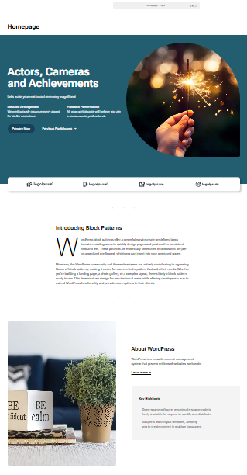

Color Palette:
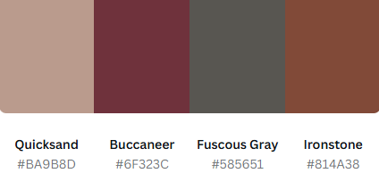

Dependencies:
Plugins:
Yoast SEO – Improves search engine optimization
Smush – Compresses images to improve performance and server load
Duplicator – Creates backups of the website and allows site migration
Akismet Anti-Spam – Protects comments from spam
WordFence Security – Provides firewall and malware protection site-wide
WPForms – Provides user-friendly registration and contact forms

Templates:
Theme Name: Bluehost Blueprint
https://wordpress.org/themes/bluehost-blueprint/

CODING PHASE
Roles Involved: -
1. Design Team
2. Developers
3. Project Manager
- Developers and design team will develop the source code for all the assigned modules, once the code is base Line they will check in into the “central repository”
- Development lead will check out all the source code from the central repository or common repository to his local machine.
- He will convert entire source code to executable code (build) then he will release the build to testing team.
CheckIn :-
- The process of uploading the files from local machine to central repository is known has checkIn.
Checkout :-
- The process of downloading the files from central repository to local machine is known as checkout.
TESTING PHASE
Roles Involved: -
1. Test Engineer
3. Project Manager
- Tester’s will review all the requirements in the document, if any uncleared requirements are identified those will be documented in review report
- Review all the uncleared requirements and provide clarifications and send it back to testing team
- Test engineers will again review the documents with clarifications
- Once the build is released to the testing team the test engineer’s will execute all the test cases on the build
- while executing if any bugs or defects identified that will be report to the developer’s
- Developer’s will fix the bugs and send it back to the testing team, testing team will check whether the bug is really fixed or not and also they will look for new bugs, if identified will again report the bugs to the developer
- These process will be continued until the build is “stable”
- The stable build will be delivered to the client
DELIVERY AND MAINTENANCE’S PHASE
- Once the build is stabled in test environment the product manager will deliver the build to the client
- Where the client will have deployed in stage environment. It is common environment for both test team and client to test the build
- Once the build is stable in stage environment then the client will deploy the build in live or production environment
- If the build is deployed in production environment, then the company will conclude that the project delivered to the client properly
- Once the project is delivered, the maintenance phase of the project will be started.
MAINTENANCE PHASE
- Once the project got delivered to the client and it is deployed in live environment the maintenances of the project will be started
- Maintenance’s is dependents on the agreement(signoff) It could be 5yrs,10yrs,15yrs etc.
- During the maintenance company is responsible to fix the bugs and up to new enhancement
- Whenever the client sends any mail with bugs or enhancements company is responsible to give any acknowledgment within the turn round time it could be 12hrs or 24hrs etc.
- As long has the project is on live the maintenance of the project should be there

