INFO-1251 Lab 4

1.
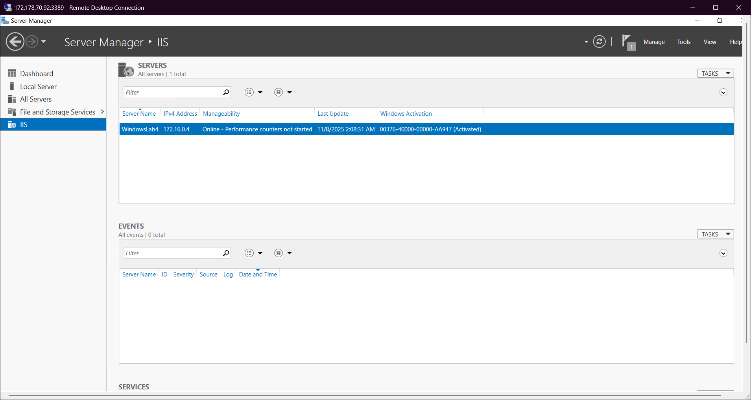
IIS installed. Screenshot taken from RDP session of Windows VM

3.
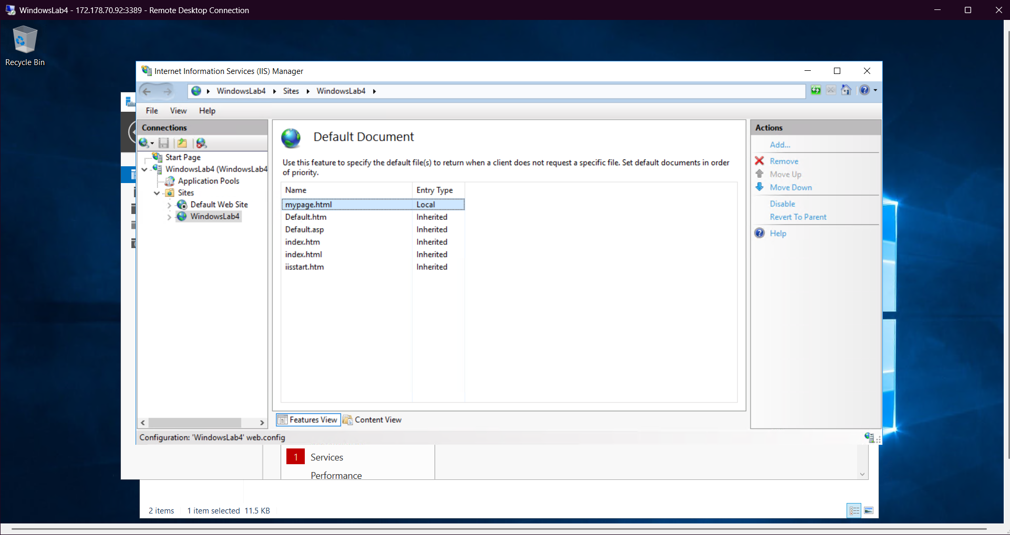
Default document changed for first website to mypage.html

5.
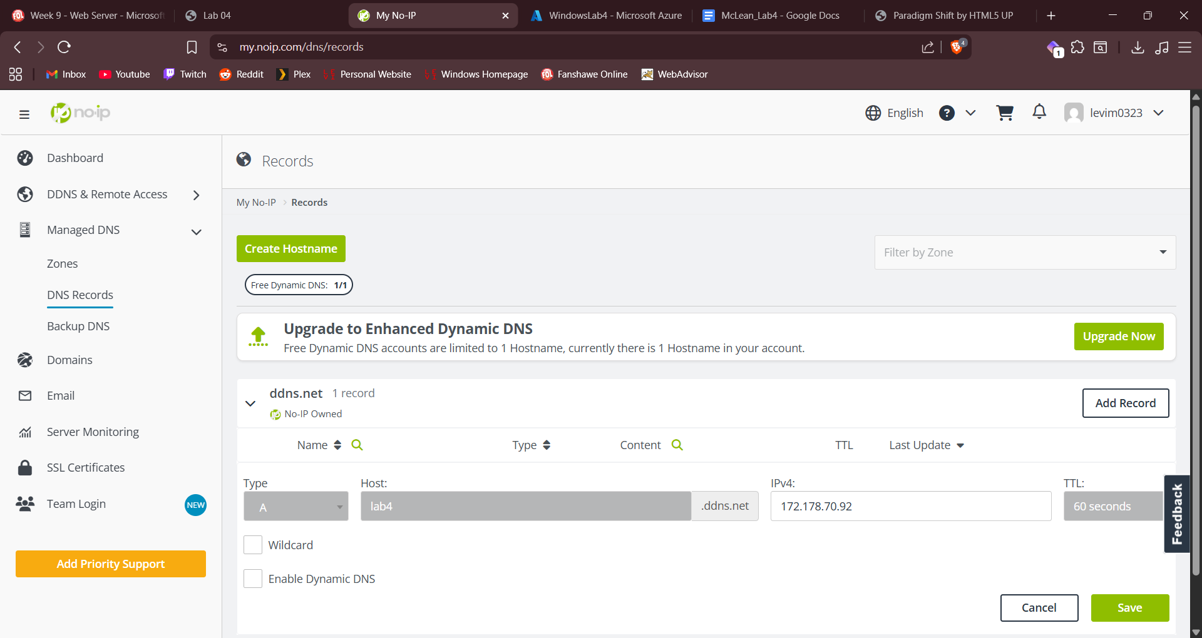
FreeNom does not appear to exist anymore, and NoIP only allows one hostname on the free plan. I will provide proof below that two websites are running with different website templates on my Azure VM. I also had to use HTML5up.net instead of free-css.com as free-css doesn’t offer free templates as far as I could see.

6.
a)
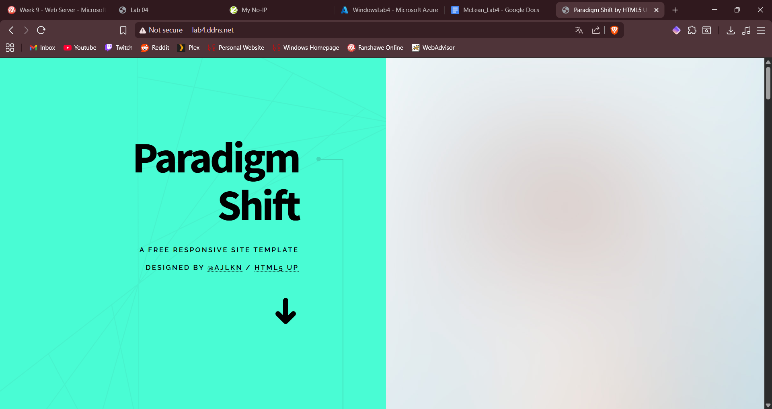
Here is the one website accessed from the No-IP hostname, second website will be the local view below

b)
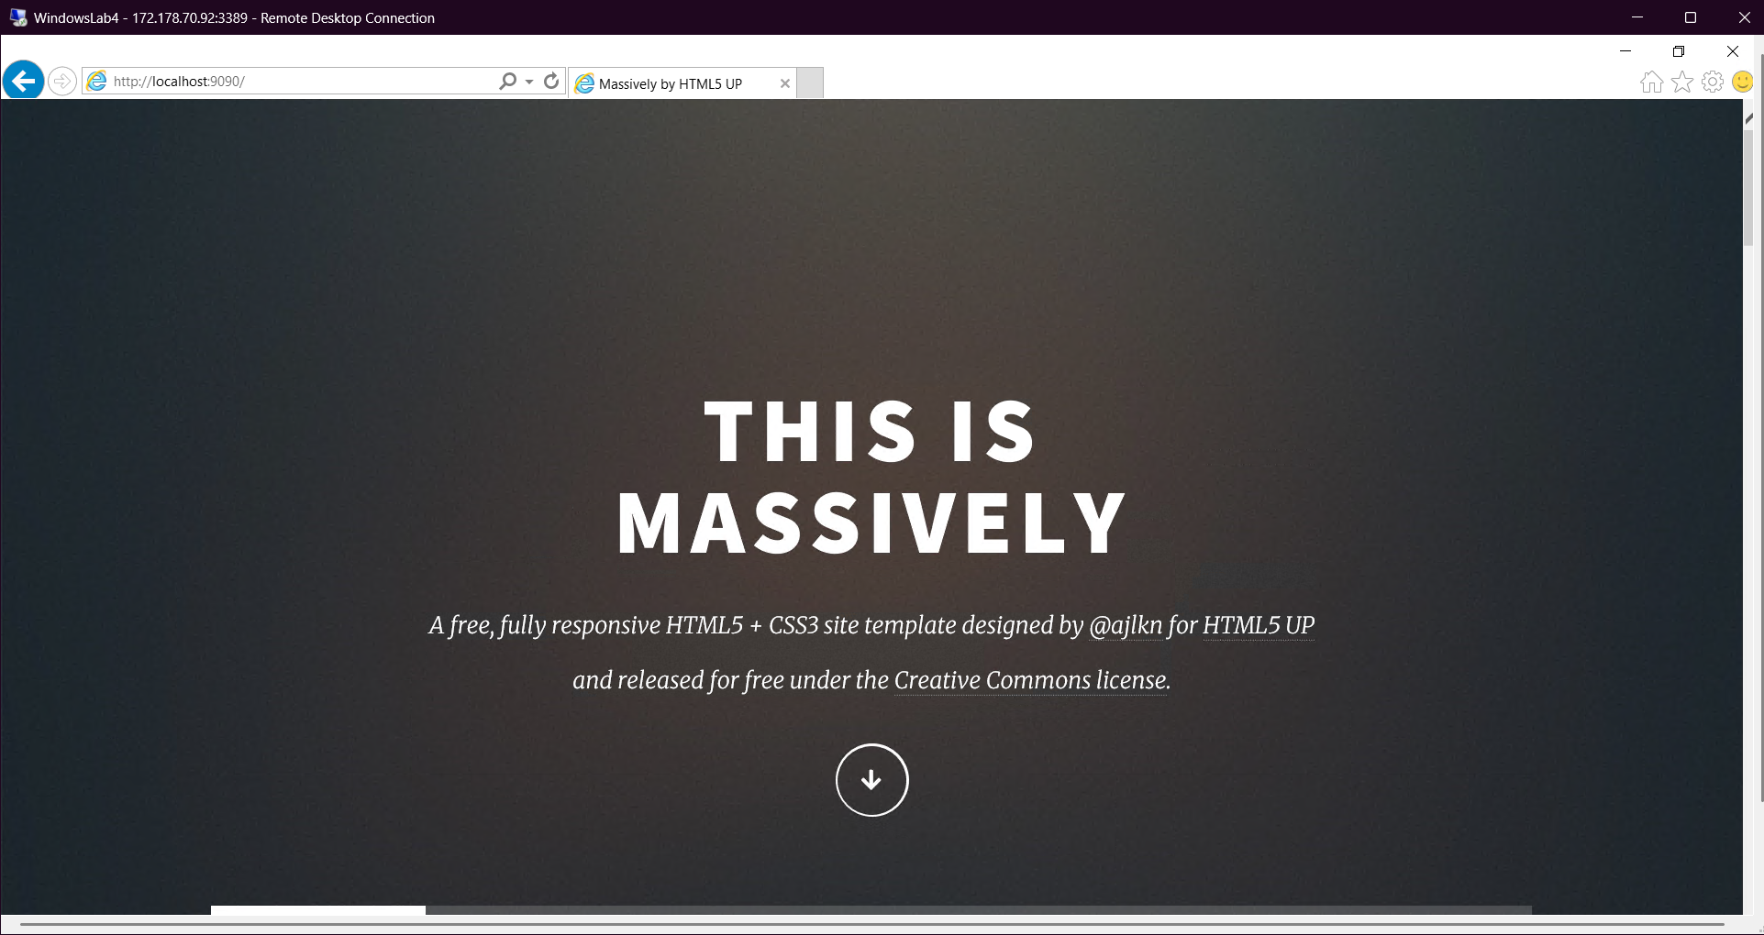
Second website, again only running locally because I could only make one hostname. Both would be accessible otherwise, I would just make another A record pointing to the same IP but on port 9090 this time.

