Your Name: Levi McLean Date: September 15th, 2025
Course: | INFO1251 (Web Server & N/W Fundamentals)  Lab # 02
Project: | INFO1251 (Web Server & N/W Fundamentals)  Lab # 02
Due Date: | As per FOL Submission Folders due date/time
Instructions and how will my lab be marked.
For each question/task provide your written answer within this document. Your written answer or explanation should be 2 to 3 sentences. If you are referencing from other sources, your last sentence will be in your own words, starting with; To summarize, …
You are to use cmd/Command Prompt for this lab assignment.
Help commands … cls – to clear the screen
/? – after the root command for help/options e.g.: c:\ping/?
For each new screenshot capture, issue this 1-line command first then the command(s) noted in the lab assignment; c:\ hostname & date /t & time /t
Example screenshot capture:
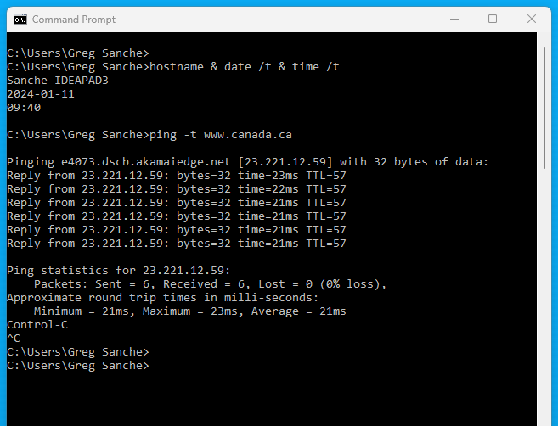
For each screenshot capture, provide a brief description of the command results.

Your explanations/questions and tasks …
Note, your explanation of each screenshot capture is an important part of your marks.
Q. |  | Marks
1 | Explain the command ‘ping’.  Use the ping command with options; -t and -a for this IPv4 address; 8.8.4.4  (2 screenshots) | 3
2 | Explain the command ‘tracert’.  Use the tracert command for this IPv4 address; 8.8.4.4  How many hops did it take to reach 8.8.4.4?  (1 screenshot) | 3
3 | Explain the command ‘netstat’.  Use the netstat command with these options; -a, -f, -r  (3 screenshots) | 3
4 | Explain the command ‘route print’.  Use the route print command and summarize the output results.  (1 screenshot) | 3
5 | Explain the command ‘nslookup’.  Use the nslookup command for google.com and google.ca  (2 screenshots) | 3
 | Total | 15
Submission Details
Add your written response to the above explanation/tasks and all the screenshot captures with supporting notes below.
Submit this Word document file to the Submission Folders/Dropbox labelled Lab 02.

Question 1
Ping -t 8.8.4.4 will cause your device to “ping” the address 8.8.4.4 until the user stops the command as opposed to the default 4 ping requests before stopping
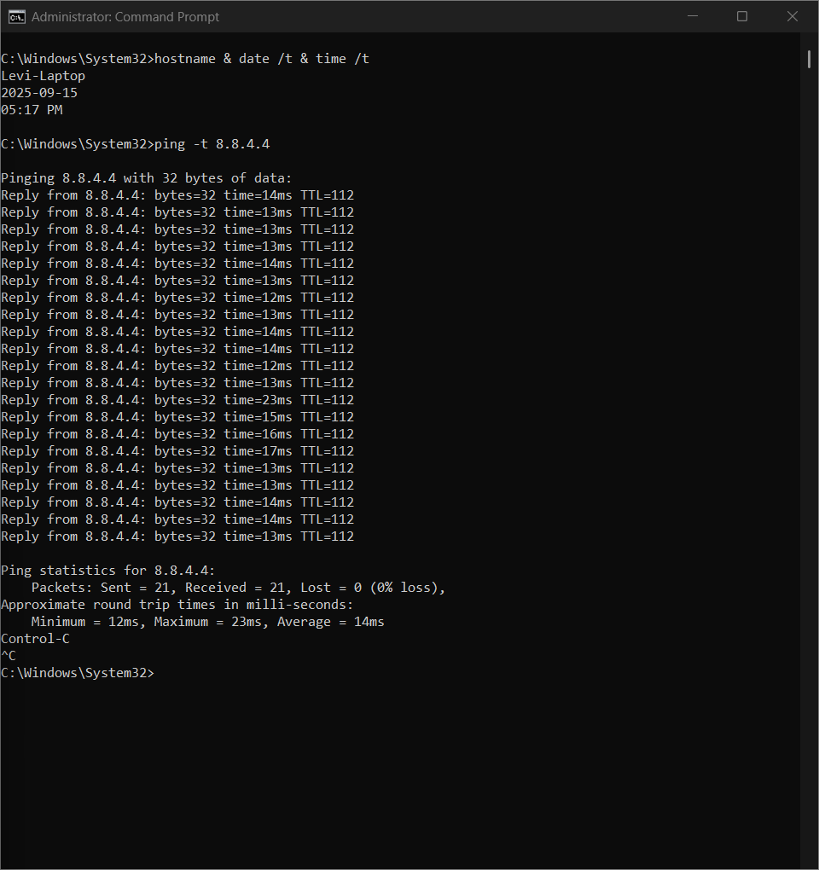
Ping -a 8.8.4.4 will resolve the hostname associated with the IP address provided. This can be either a domain or a device name, depending on what device you ping, in this case dns.google
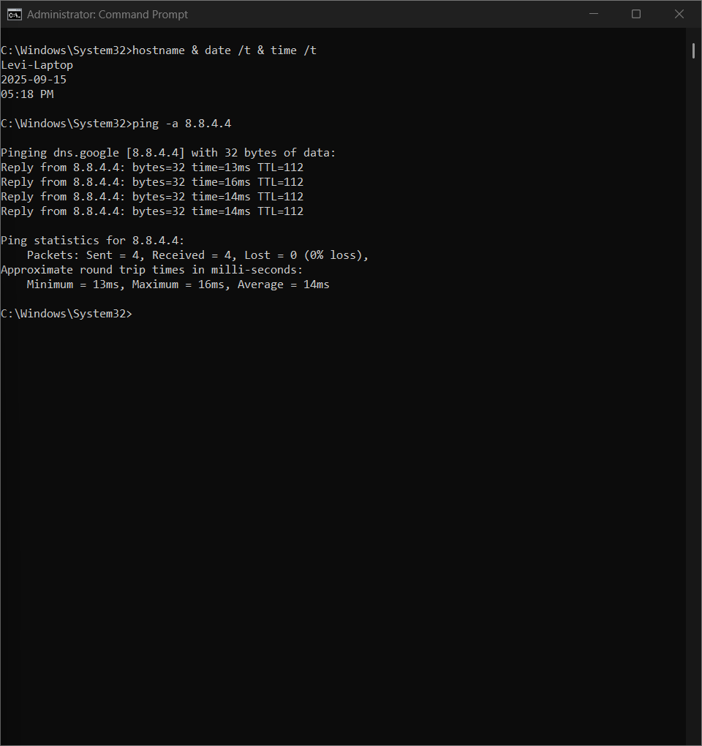
Question 2
This command, as the name suggests, traces the route to a designated IP address. It makes “hops” between different devices (or IPs) until it reaches the destination IP or reaches the maximum amount of hops
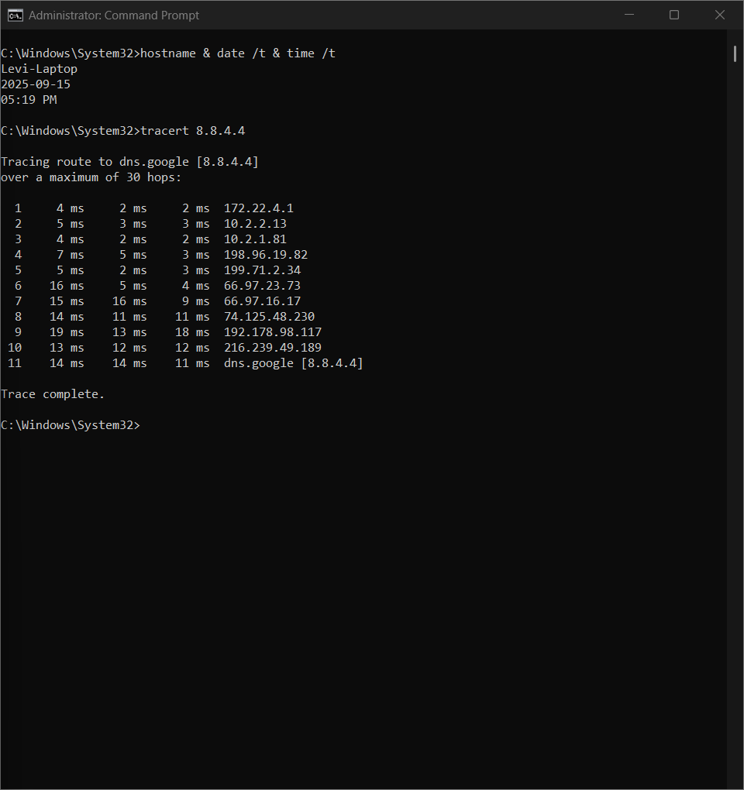

Question 3
Netstat -a essentially shows all connections with just simple IP addresses and ports in use as well as what state that connection is in
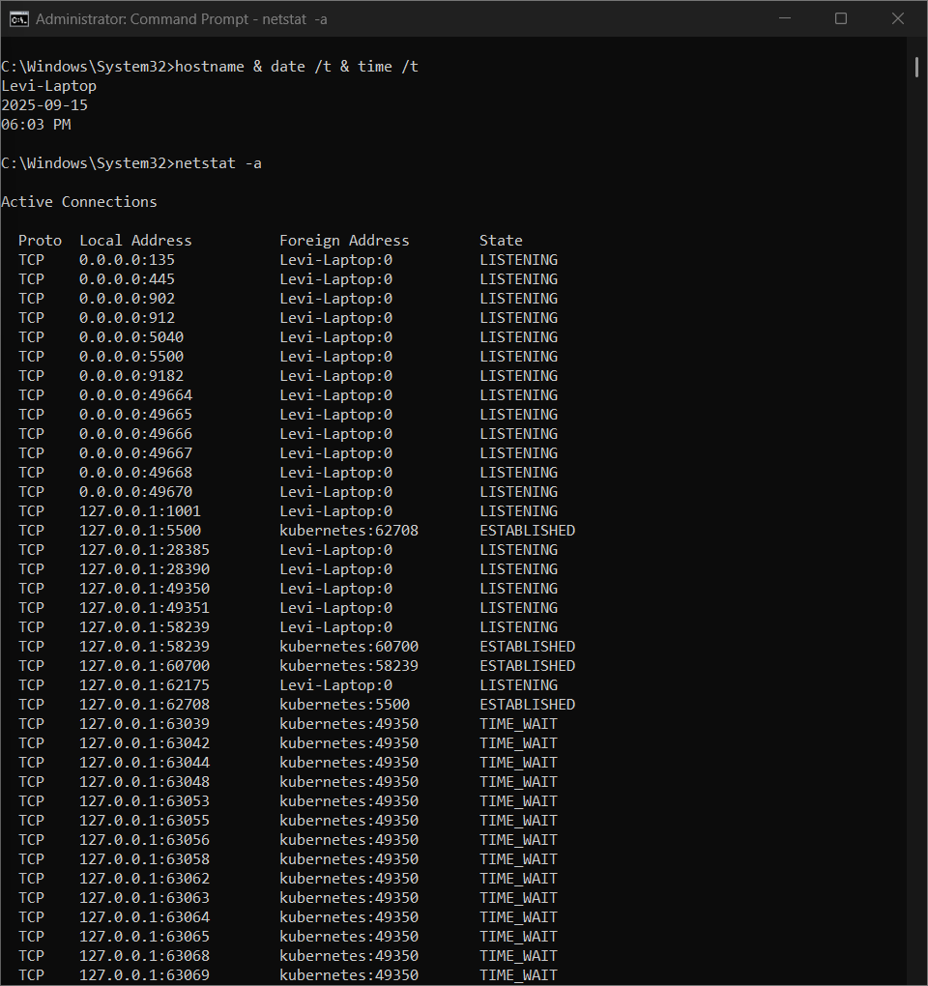
Netstat -f does roughly the same thing as netstat -a except it shows a full domain name for the foreign addresses (the address your device is connecting to)
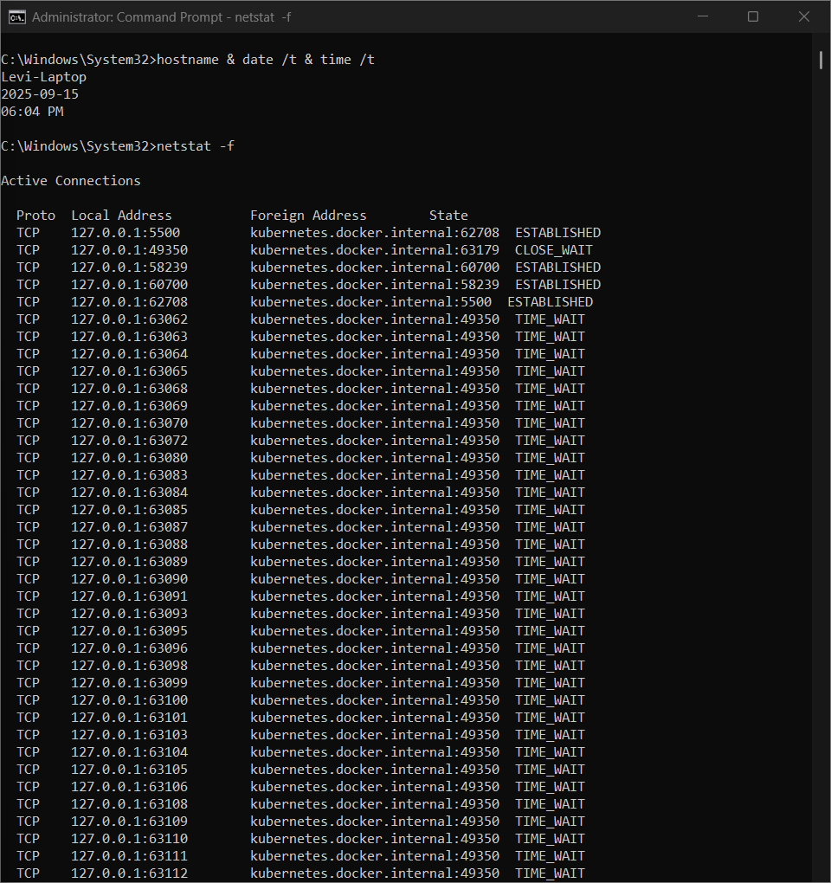
Netstat -r shows the routing table for the device it is ran on. This means that it shows which interfaces use which ip addresses, subnet masks, gateways and etc.
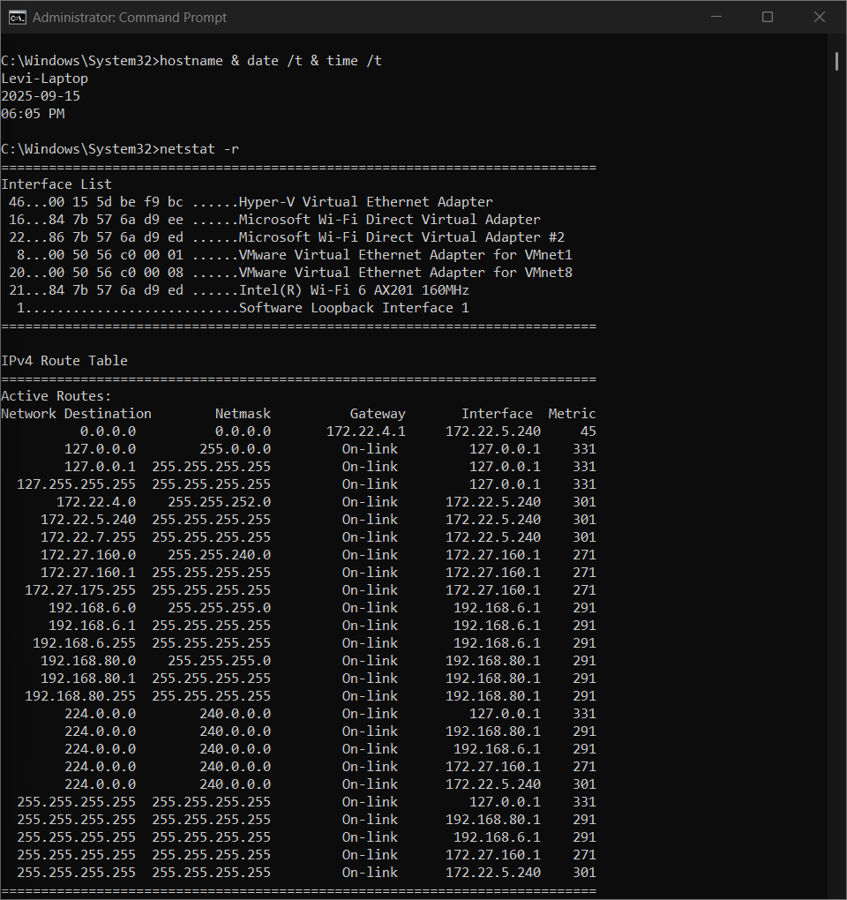

Question 4
Route print does about the exact same thing as netstat -r by printing the routing table
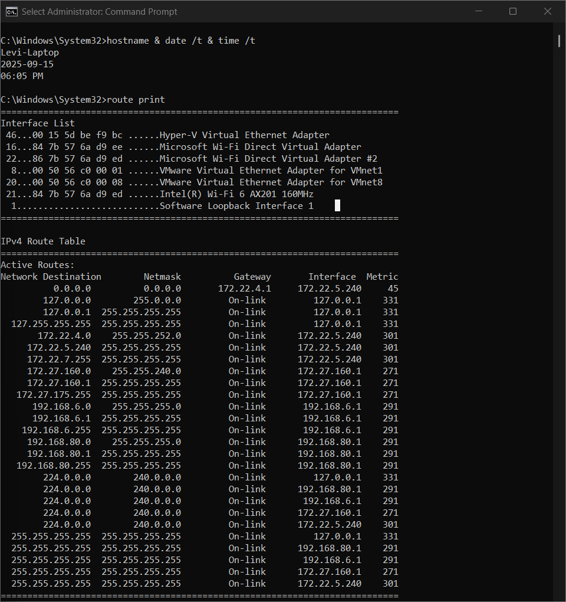

Question 5
Nslookup is a command used to find information about what device(s) are hosting a certain domain by returning the IP address associated with it.
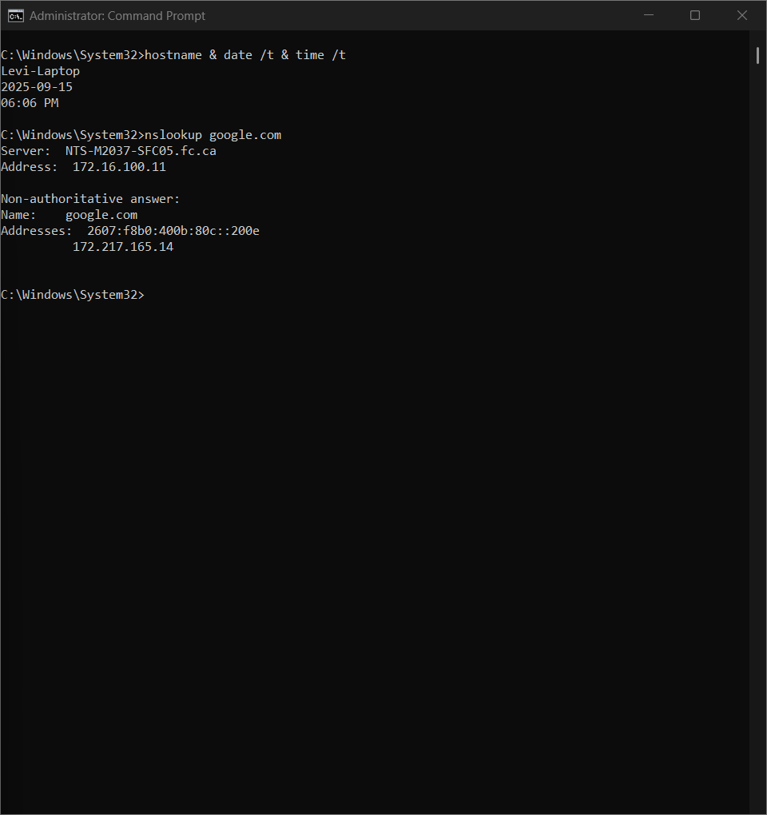

Google.com and Google.ca are two different domains (their TLDs are different), therefore google.ca will be hosted on a different server with a different IP address than Google.com
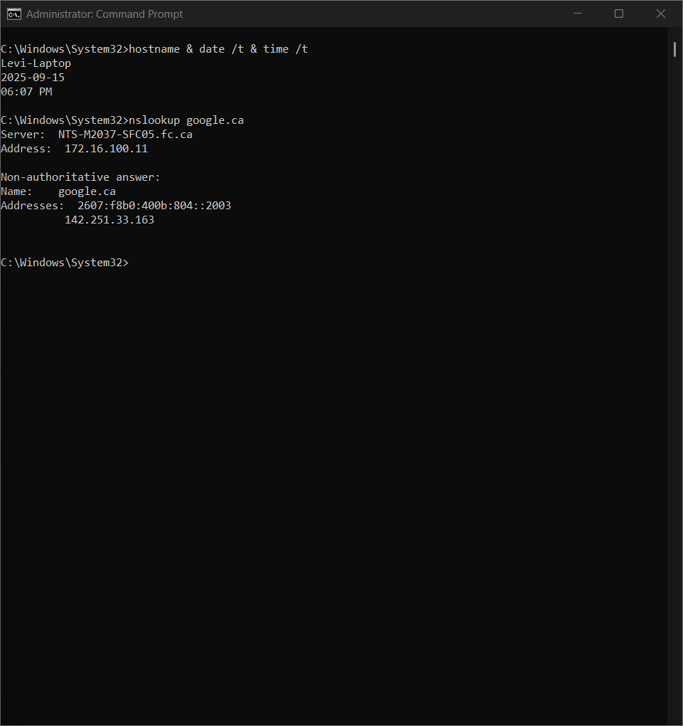

©2025 Fanshawe College Lab #02 INFO1251, 25W

